# **ASSIGNMENT - 1**

# **SMOKE CHECK LIST OF VOGO WEB APPLICATION**

|  |  |  |
| --- | --- | --- |
| **S.NO** | **FUNCTIONALITY** | **STATUS** |
| 1 | VOGO logo or home tab | Pass |
| 2 | About us | Pass |
| 3 | Careers | Pass |
| 4 | Help | Pass |
| 5 | Option for downloading the mobile application of VOGO for Android users | Pass |
| 6 | Option for downloading the mobile application of VOGO for Apple users | Pass |
| 7 | Get Started | Pass |
| 8 | Page UI | Pass |
| 9 | VOGO now | Pass |
| 10 | ‘VOGO Keep’ and ‘Book Now’ button | Pass |
| 11 | Login with mobile no. OTP and Login Button | Pass |
| 12 | ‘More about us’ button | Pass |
| 13 | Displaying types of vehicles available for rent with proper specifications and cost of ride in Rs/Km | Pass |
| 14 | Footer | Pass |

# **ASSIGNMENT - 2**

**2.Test Scenarios and Test Cases of Pen**

1. Verify GUI/UI of the Pen
2. Verify the material/ dimension/ body of the Pen
3. Verify the Refill of the Pen
4. Verify the writing functionality of the Pen

**Scenario 1:** Verify GUI/UI of the Pen.

**Test Cases**

1. Verify the pen visibility🡪 ER – Some pen should visibility
2. Verify the outer & cap color of the pen
3. Verify the logo present in the pen
4. Verify the brand name on pen
5. Verify the text on pen

**Scenario 2:** Verify the material/ dimension/ body of the Pen.

**Test Cases**

1. Verify the material body of the Pen
2. Verify the material Cap of the Pen
3. Verify the material Refill of the Pen
4. Verify the material grip of the Pen
5. Verify the material nib of the Pen
6. Verify the dimension/ length/size/weight of the Pen
7. Verify the dimension/ length/size/ weight of the Cap
8. Verify the dimension/ length/size/ weight of the Refill
9. Verify the dimension/ length/size/ weight of the nib

**Scenario 3:** Verify the Refill of the Pen.

**Test Cases**

1. Verify Refill types of the Pen
2. Verify ink present in Refill of the Pen
3. Verify color of ink present in Refill of the Pen
4. Verify Viscosity of ink present in Refill of the Pen
5. Verify ink present in Refill of the Pen
6. Verify life of ink present in Refill of the Pen
7. Verify quantity of ink present in Refill of the Pen
8. Verify leakages of ink present in Refill of the Pen
9. Verify reusable Refill of the Pen

**Scenario 4:** Verify the writing functionality of the Pen.

**Test Cases**

1. Verify the writing capacity and smoothness of the Pen.
2. Verify the writing capacity of the Pen on white paper with black ink.
3. Verify the writing capacity of the Pen on black paper with black ink.
4. Verify the writing capacity of the Pen on stone with black ink.
5. Verify the writing capacity of the Pen on wood paper with black ink.
6. Verify the writing capacity of the Pen on rough surfaces paper with black ink.
7. Verify the writing capacity of the Pen against anti-gravity.
8. Verify the writing capacity of the Pen in water on a paper with black ink.
9. Verify the writing capacity of the Pen on black paper with black ink.
10. Verify the writing capacity of the Pen with high temperature and low temperature with black ink.
11. Verify the writing capacity of the Pen high altitude with black ink.
12. Verify the writing capacity of the Pen with two refills.
13. Verify the writing capacity of the Pen with three refills.
14. Verify the writing capacity of the reusable Pen.
15. Verify the writing capacity of the use and throw Pen.
16. Verify the button on the Pen.

# **ASSIGNMENT – 3**

**User Stories**

**User Story 0001:** Add the Hindi currency format option

**Description:** The scope of this US is to provide currency details in Hindi so that users can see the rupees option in Hindi. And after applying this option all the fare should appear in Hindi digit.

**Acceptance Criteria:**

* + 1. Users are able to click रुपैया Radio button
    2. रुपैया Radio button is displayed after the INR radio button (as per the mockup)
    3. Users are able to select INR or रुपैया Radio button at the same time

**Mockup:**

**Part 1 Instructions**

In the Make My Trip application as per the client requirement the development team is adding a new radio button i.e.. "रुपैया " for this functionality all the mockups  and acceptance criteria are present in the user story. Please go through the user story and complete all the subtasks.

**Subtasks**

* + 1. Write the test scenario and test cases based on the acceptance criteria for the newly implemented functionality

Ans: Check the Answer by scrolling down the Page.

* + 1. Estimate your testing effort (Provide the story point) how much time you will require to complete the QA testing activity.

Ans : 1 story point

* + 1. While testing the newly implemented functionality you find the bug i.e.. Radio button is not working. What is the priority you will estimate for this issue.

Ans: Priority is High.

* + 1. Provide the severity for the same issue.

Ans: Severity is medium

* + 1. Prepare the Regression checklist for the newly implemented functionality.

|  |  |  |
| --- | --- | --- |
| **S.no** | **Regression Check List/ Fuctionality** | **Status** |
| 1 | “Introducing MyBiz” button | Pass |
| 2 | “My Trips” button | Pass |
| 3 | Dropdown of “Login and Create account button” | Pass |
| 4 | Checking “Select country “dropdown list. | Pass |

**Test Scenarios of User Story 0001- Add the Hindi Currency Format Option.**

1. Verify the GUI/UI of “रुपया” radio button.
2. Verify the positioning of the “रुपया” radio button.
3. Verify User should select the “रुपया” radio button or “INR” radio button at same time.

**Scenario 1: Verify the GUI/UI of “रुपया” radio button**.

|  |  |  |  |  |
| --- | --- | --- | --- | --- |
| **Sr No** | **Test Case** | **Expected Result** | **Test Data** | **Test Status** |
| 1 | Launch the Make my trip application as per the test data | User should be able to launch MMT Application | <https://www.makemytrip.com/> | Pass |
| 2 | Click on the Country Drop down list | User should be able to click on the Dropdown list and by default 'India' country is selected |  | Pass |
| 3 | After clicking on the India from select country button, check the radio button and labels is visible or not. | User should be able to see the "रुपैया" radio button in dropdown list after selecting country as 'India'. |  | Pass |
| 4 | Verify the spelling of the labels of radio button | User should able to see the correct Hindi spelling of the "रुपैया" in the radio button |  | Pass |
| 5 | Verify the text colour and style of the labels (रुपैया) of radio button | User should able to see the black colour on the text of "रुपैया" radio button and style of font as per the mock up. |  | Pass |

|  |  |  |  |  |
| --- | --- | --- | --- | --- |
| **Scenario 2: Verify the positioning and dimensions of the “रुपया” radio button.** | | | |  |
|  |  |  |  |  |
| **Sr No** | **Test Case** | **Expected Result** | **Test Data** | **Test Status** |
| 1 | Launch the Make my trip application as per the test data | User should be able to launch MMT Application | <https://www.makemytrip.com/> | Pass |
| 2 | Verify the position of the radio button as per the mock-up | User should be able to see the “रुपैया" radio button just below the "INR" radio button as per the mock up. |  | Pass |
| 3 | Verify the size of the radio button | Size of the radio button should be perfect as per the mock up. |  | Pass |
| 4 | Verify the alignment of the radio button | Alignment of the radio button should be perfect as per the mock up. |  | Pass |
| 5 | Verify the shape of the radio button | Shape of radio should be circle as per the mock up |  | Pass |
| 6 | Verify the label's text size "रुपैया" of the radio button | Text Size of the label "रुपैया" should be perfect and according to the mock up. |  | Pass |
| 7 | Verify the label's text alignment "रुपैया" of the radio button | Text Alignment of the label "रुपैया" should be perfect and according to the mock up. |  | Pass |

|  |  |  |  |  |
| --- | --- | --- | --- | --- |
| **Scenario: 3 Verify the user should be able to select ‘“रुपया” radio button.** | | | |  |
| **S.no** | **Test Case** | **Expected Result** | **Test Data** | **Test Pass** |
| 1 | Launch the Make my trip application as per the test data | User should be able to launch MMT Application | <https://www.makemytrip.com/> | Pass |
| 2 | Click on the Country Drop down list | User should be able to click on the Dropdown list and by default 'India' country is selected |  | Pass |
| 3 | Verify whether cursor of mouse should be changing while hovering on Select country option. | Mouse Cursor icon should be changed while hovering on the Select country option button. |  | Pass |
| 4 | Verify by Selecting on “रुपैया" radio button | User should be able to select the “रुपैया" radio button. |  | Pass |
| 5 | After Selecting "रुपैया" radio button, the colour should be changed as per the requirements | After Selecting "रुपैया" radio button, colour of radio should be changed to blue as per the mock-up. |  | Pass |
| 6 | After selecting " language option as Hindi", user should able to select only one Currency option at same time. | User should able to select one currency option between "INR" and"रुपैया" radio button as per the mock-up |  | Pass |
| 7 | After selecting " language option as English", user should able to select only one Currency option at same time. | User should able to select one currency option between "INR" and"रुपैया" radio button as per the mock up. |  | Pass |
| 8 | Verify by selecting on both the currency options at same time. | User should not be able to select both the currency option i.e., "INR" and"रुपैया" radio button at the same time as per the mock up. |  | Pass |

**User Story 0002:** Make my trip modified Logo

**Description:** The scope of this US is to make a new company logo. Check the modified logo in the mockup

**Acceptance Criteria:**

* + 1. Upon clicking on the ‘Explore the World’ link system will navigate to Where2Go- by MakeMyTrip page
    2. Where2Go- by MakeMyTrip page will be open in a separate window.

**Mockup:**

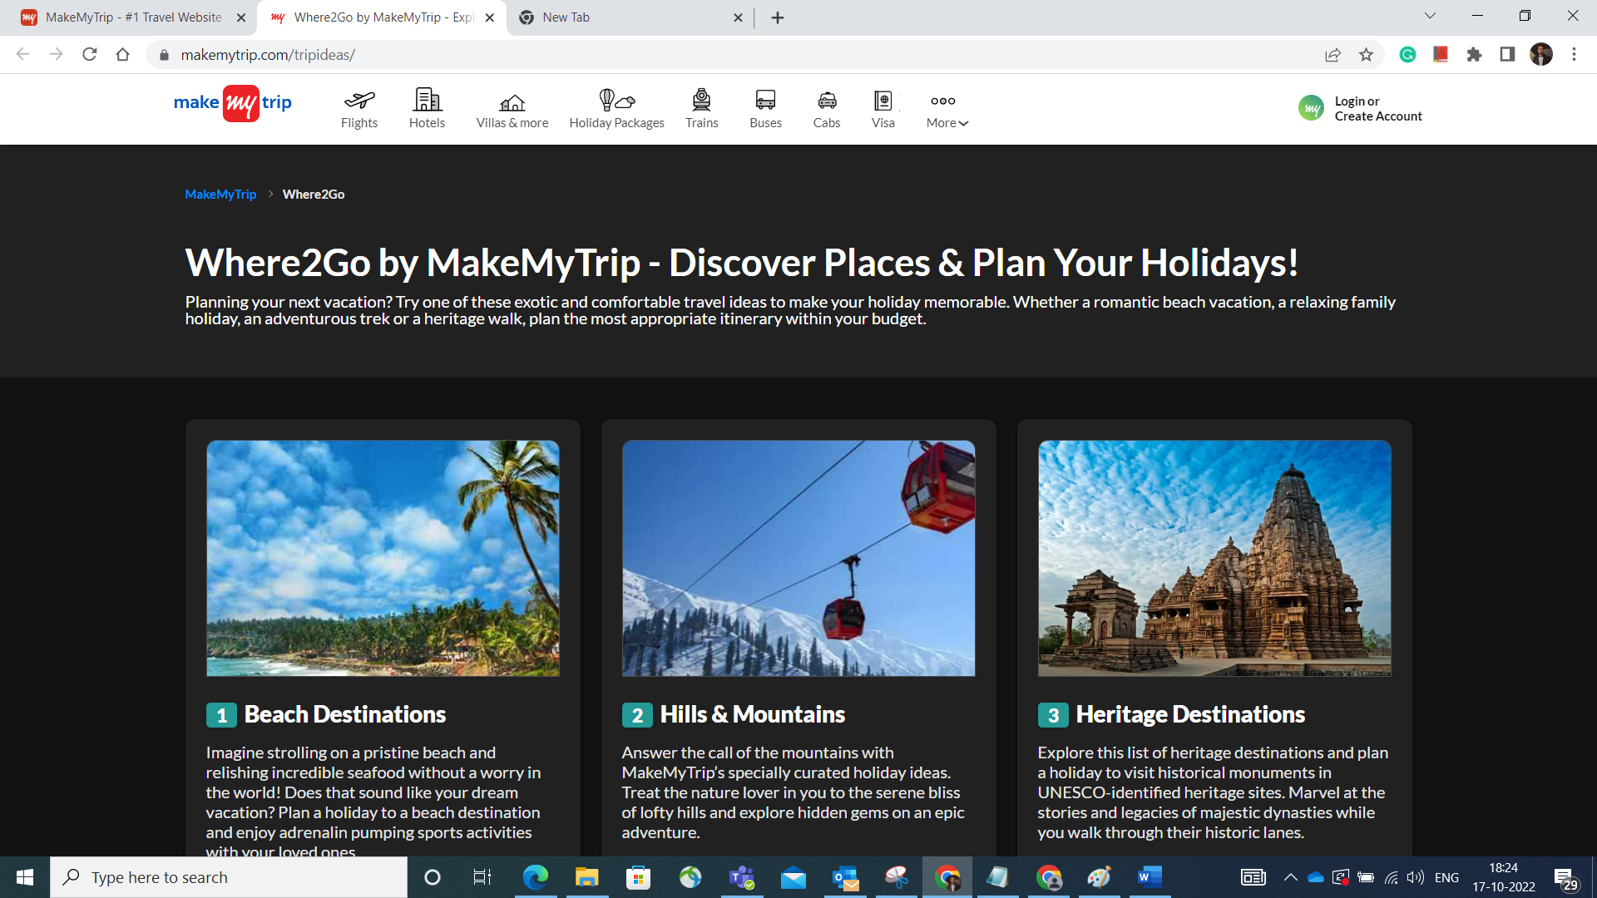

STAFF DEBUG INFO

**Subtasks**

1. Write the test scenario and cases based on the acceptance criteria for the newly implemented functionality.

**Test Scenarios of user story 0002: Make My Trip modified logo**

1. Verify the user interface of Modified logo button of Make My Trip.
2. Verify the dimensions of Modified logo on Make My Trip page.
3. Verify the functionality of modified logo by clicking on “Explore the world” Link.
4. Verify the navigation page after clicking on “Explore the world” link.

|  |  |  |  |  |
| --- | --- | --- | --- | --- |
| **Scenario1: Verify the user interface of Modified logo button of Make My Trip.** | | | |  |
|  |  |  |  |  |
| **Column1** | **Column2** | **Column3** | **Column4** | **Column5** |
| **Sr No** | **Test Case** | **Expected Result** | **Test Data** | **Test Status** |
| 1 | Launch the Make my trip application as per the test data | User should be able to launch MMT Application | <https://www.makemytrip.com/> | Pass |
| 2 | Verify the visibility of new logo of make my trip application. | User should be able to see the logo of mmt application. |  | Pass |
| 3 | Verify the visibility "Explore the world" link | User should be able to see the "Explore the world" in the modified application |  | Pass |
| 4 | Verify the correct name and spellings of the Modified logo including the “Explore the world" link | User should able to see the name with proper spelling of the logo as well as link "Explore the world" in modified application as per the mock up. |  | Pass |
| 5 | Verify the Font colour and style of the modified logo | User should able to see the White colour on the text of link “Explore the world" button and style of font as per the mock up. |  | Pass |
|  |  |  |  |  |
| **Scenario 2: Verify the dimensions of Modified logo of Make My Trip page.** | | |  |  |
|  |  |  |  |  |
| **Sr No** | **Test Case** | **Expected Result** | **Test Data** | **Test Status** |
| 1 | Launch the Make my trip application as per the test data | User should be able to launch MMT Application | <https://www.makemytrip.com/> | Pass |
| 2 | Verify the position of the Logo as per the mock up | Position of logo of Make my trip should be proper placed according to the mock up. |  | Pass |
| 3 | Verify the Text size of the logo | Text Size of the Logo button should be perfect as per the mock up. |  | Pass |
| 4 | Verify the alignment of the logo | Alignment of the Logo button should be perfect as per the mock up. |  | Pass |
| 5 | Verify the position of the “Explore the world" link button. | Position of the "Explore the world" link should be below the "Make my trip" logo button as per the mock up |  | Pass |
| 6 | Verify the Text size of the “Explore the world" link button | Text Size of the “Explore the world" link should be smaller than the "Make my trip" logo button according to the mock up. |  | Pass |
| 7 | Verify the alignment of the "Explore the world" link button | Alignment of the "Explore the world" link should be perfect and according to the mock up. |  | Pass |
|  |  |  |  |  |
| **Scenario3: Verify the functionality of modified logo by clicking on “Explore the world” Link.** | | | |  |
| **S.no** | **Test Case** | **Expected Result** | **Test Data** | **Test Status** |
| 1 | Launch the Make my trip application as per the test data | User should be able to launch MMT Application | <https://www.makemytrip.com/> | Pass |
| 2 | Verify the cursor of mouse should be changing while hovering on "Explore the world" link. | Mouse Cursor icon should be changed while hovering on "Explore the world" link. |  | Pass |
| 3 | Verify by Clicking on the "Explore the world" link in Mozilla Firefox browser. | User should be able to click on the "Explore the world" link. |  | Pass |
| 4 | Verify by Clicking on the "Explore the world" link in Microsoft Edge browser | User should be able to click on the "Explore the world" link. |  | Pass |
| 5 | Verify by Clicking on the "Explore the world" link in Chrome browser | User should be able to click on the "Explore the world" link. |  | Pass |
| 6 | Verify by Clicking on the "Explore the world" link in Opera Mini browser | User should be able to click on the "Explore the world" link. |  | Pass |
|  |  |  |  |  |
| **Scenario 4: Verify the navigation page after clicking on “Explore the world” link.** | | | | |
|  |
|  |  |  |  |  |  |
| **S.no** | **Test Case** | **Expected Result** | **Test Data** | **Test Status** |  |
| 1 | Launch the Make my trip application as per the test data | User should be able to launch MMT Application | <https://www.makemytrip.com/> | Pass |  |
| 2 | After Clicking on "Explore the world" link, user will able to navigate on new tab on Chrome Browser. | User should be redirected to new tab of browser |  |  |  |
| 3 | After Clicking on "Explore the world" link, user will able to navigate on new tab on Mozilla Firefox Browser. | User should be redirected to new tab of browser |  | Pass |  |
| 4 | After Clicking on "Explore the world" link, user will able to navigate on new tab on Opera Mini Browser. | User should be redirected to new tab of browser |  | Pass |  |
| 5 | After Clicking on "Explore the world" link, user will able to navigate on new tab on Microsoft Edge Browser. | User should be redirected to new tab of browser |  | Pass |  |
| 6 | After clicking on “Explore the world" link, verify the new tab redirecting to "Where 2 Go" page in Chrome Browser. | User should able to get on "Where 2 Go" page on separate window i.e., on new tab. |  | Pass |  |
| 7 | After clicking on “Explore the world" link, verify the new tab redirecting to "Where 2 Go" page in Mozilla Firefox Browser. | User should able to get on "Where 2 Go" page on separate window i.e., on new tab. |  | Pass |  |
| 8 | After clicking on “Explore the world" link, verify the new tab redirecting to "Where 2 Go" page in Microsoft Edge Browser. | User should able to get on "Where 2 Go" page on separate window i.e., on new tab. |  | Pass |  |
| 9 | After clicking on “Explore the world" link, verify the new tab redirecting to "Where 2 Go" page in Opera Mini Browser. | User should able to get on "Where 2 Go" page on separate window i.e., on new tab. |  | Pass |  |

1. Estimate your testing effort (Provide the story point) how much time you will require to complete the QA testing activity.

**Ans: Story Point - 1**